**User Guide for Finish Your Milk**

Finish Your Milk is a web application that aims to remind you of your responsibilities, while giving you the flexibility of choosing what to do first. In the event that you have difficulties selecting a task, we will return suggestions for you.

**System features**

**Welcome Page**

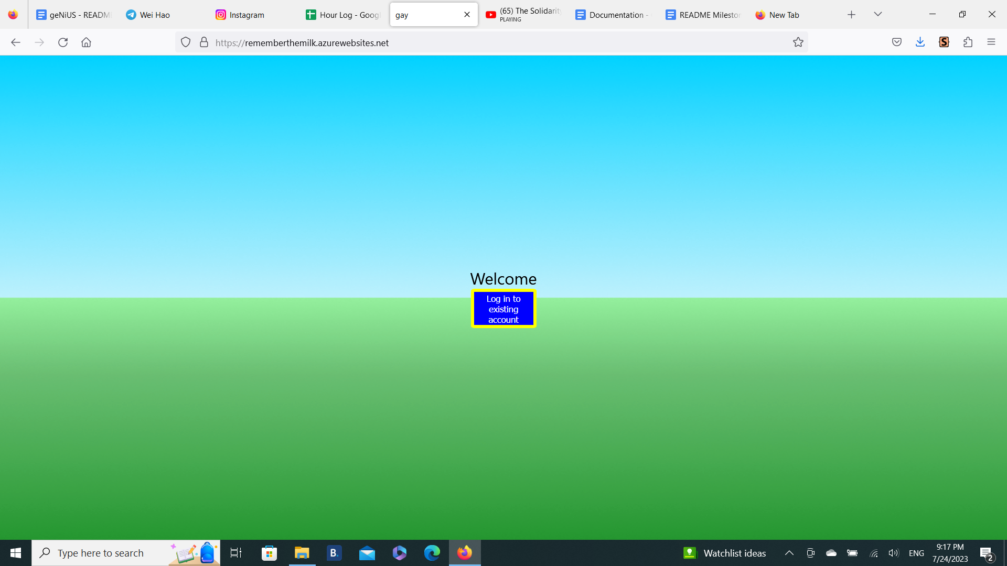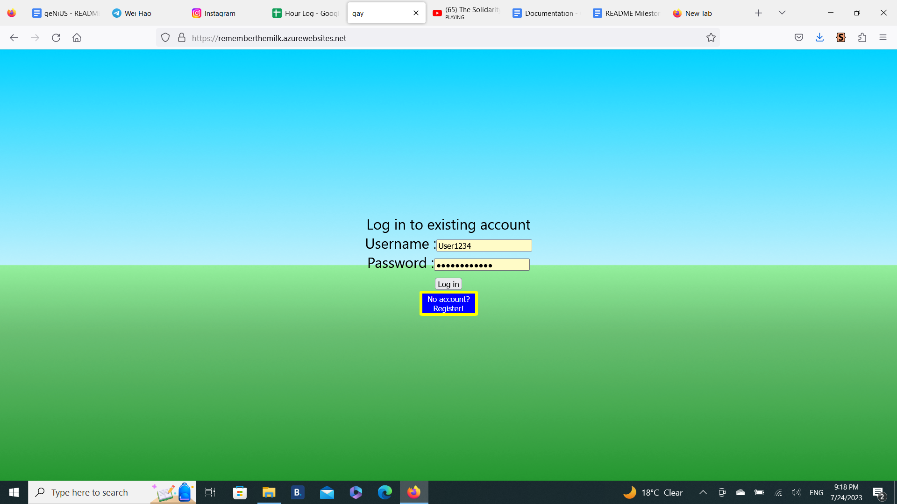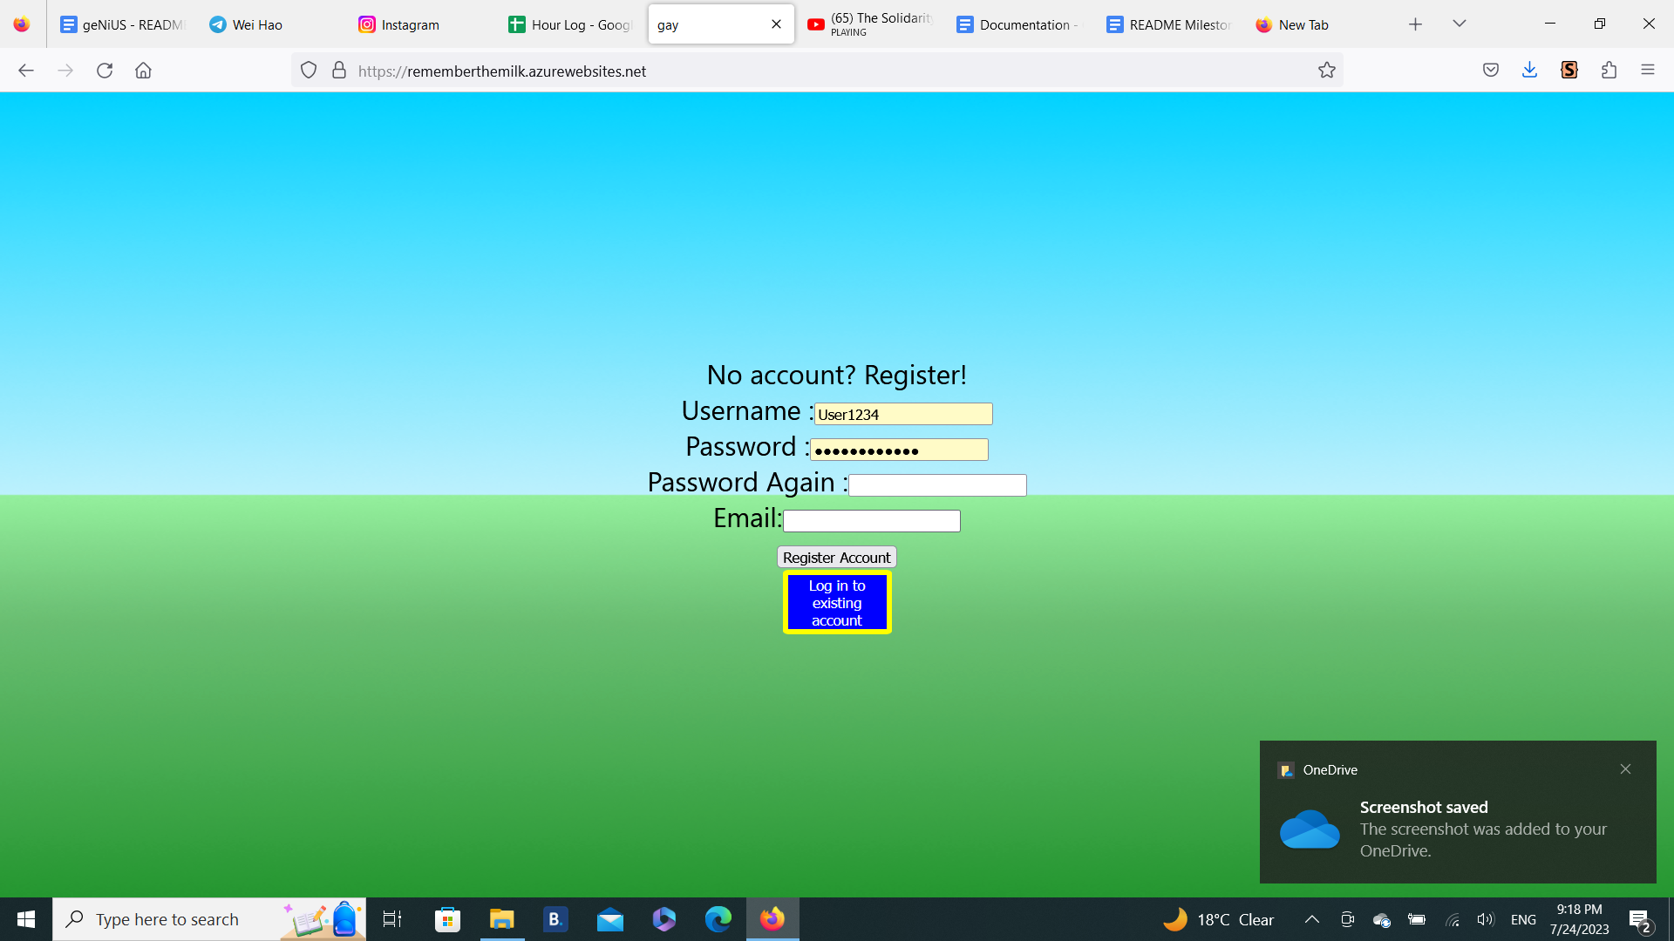

Figure 1.1: Welcome Page Figure 1.2: Login Page Figure 1.3:Register Page

When you first open the app, the Welcome page will pop up first. Clicking on the button will take you to the Login Page.

**Login Page**

If you have an existing account, you will have to enter your username and password to gain access. Otherwise, the blue button below the login button will take you to the Register Page.

**Register Page**

If you want to create a new account, you will have to input a unique username with the following constraints:

* No Spaces between characters
* No special characters (!@#$ etc.)
* Underscores are allowed (_)

Your password will also have to comply with the following:

* Must have at least 1 Capital Letter
* Must have at least 1 number
* Must have at least 8 characters

To ensure that you really remember your password, you will have to enter your password twice when registering your account. The last piece of information you have to provide is your email address for authentication purposes.

After successful registration, you will receive an email that contains a link that expires in 15 minutes to activate your account. After clicking on the link, you will be directed to the Welcome Page after being notified whether the authentication was successful. If the authentication was successful, then you can proceed to login with your username and password. Otherwise, you will have to repeat the registration process.

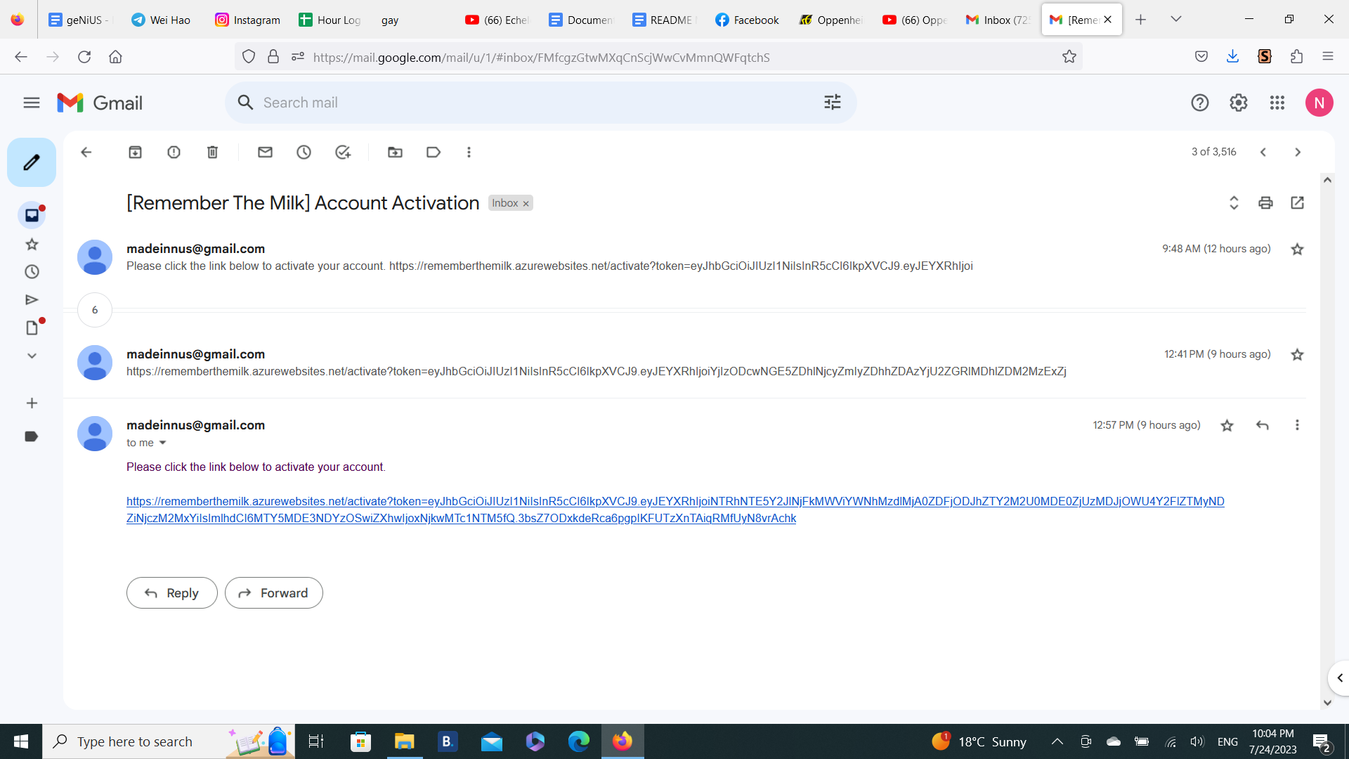

Figure 1.4: Email to receive after registration

**Navigation Bar**

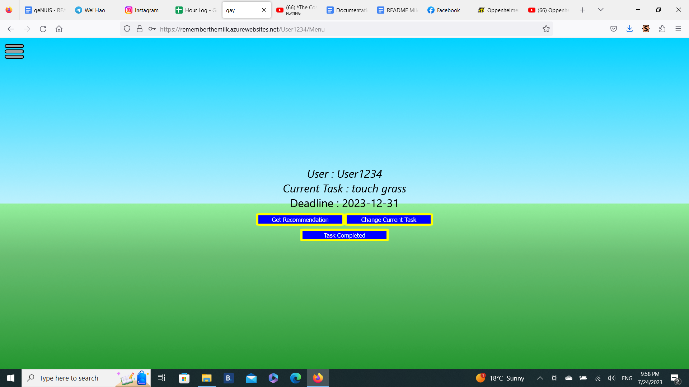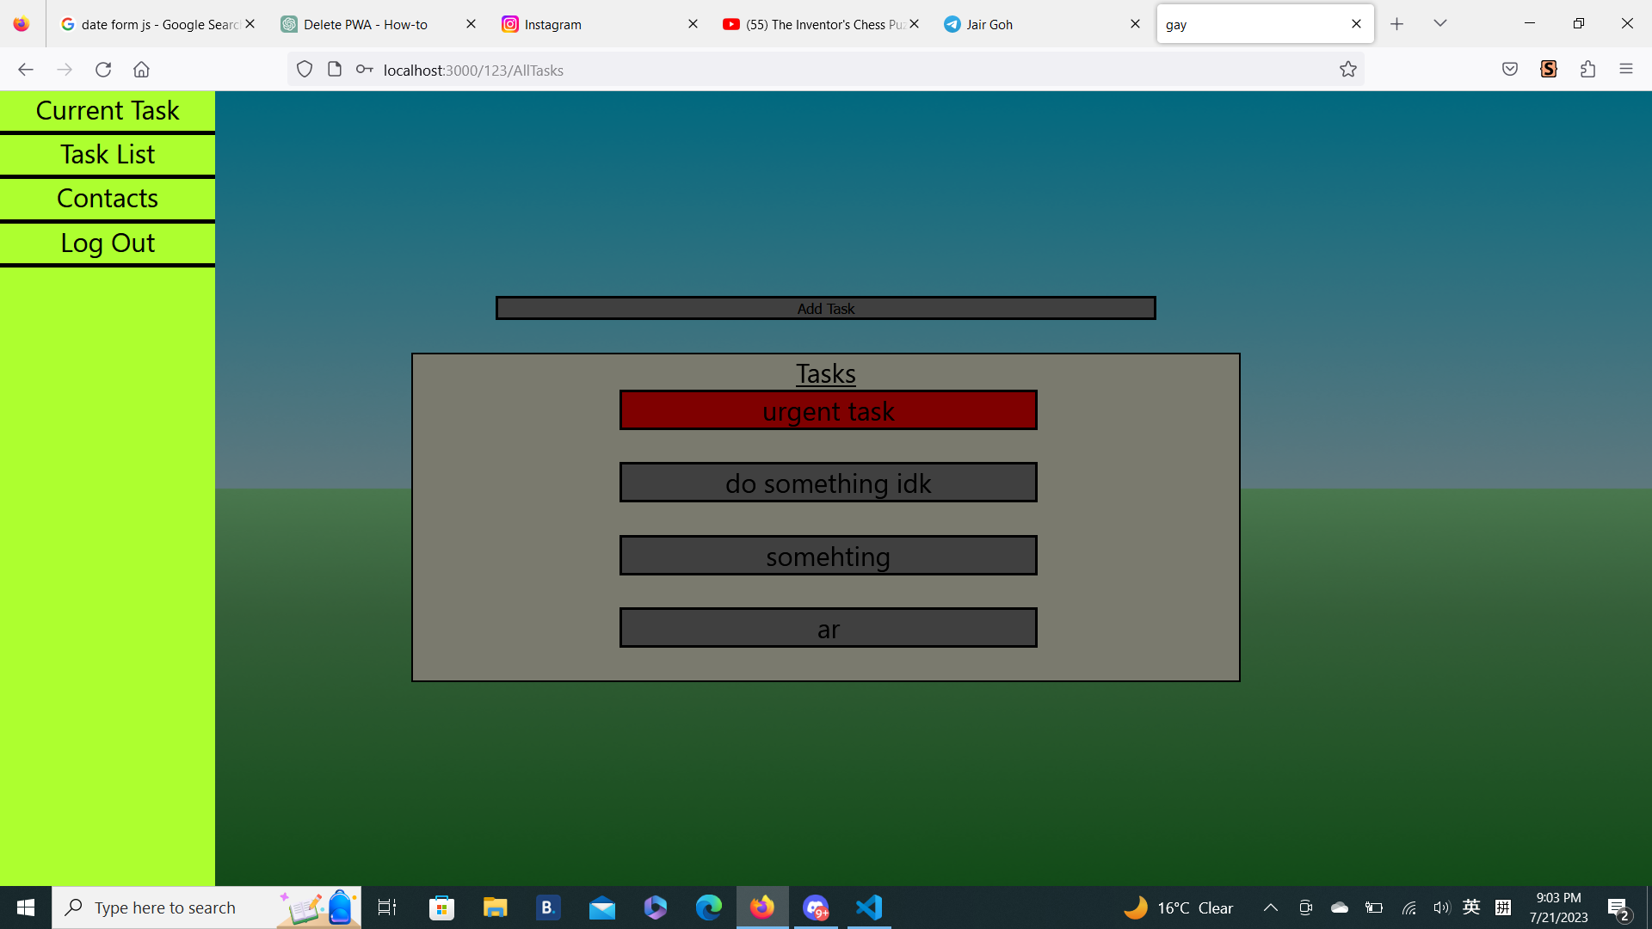

Figure 2.1: Navigation bar icon Figure 2.2: Navigation bar

Every page (excluding Welcome, Login and Register Page) will contain the navigation bar to let you easily checkout certain pages of the app. The Log out button will take you to the Welcome page and you will have to enter your username and password again to gain access. Clicking outside the navigation bar after opening it automatically closes the navigation bar.

**View Current Task**



Figure 3: Current Task Page (Main Menu)

After logging in successfully, you will be brought to this page, where your username, current task and its deadline is shown. After you have completed the task, you can click on the “Task Completed” button and choose your next task to complete.

**View All Tasks**

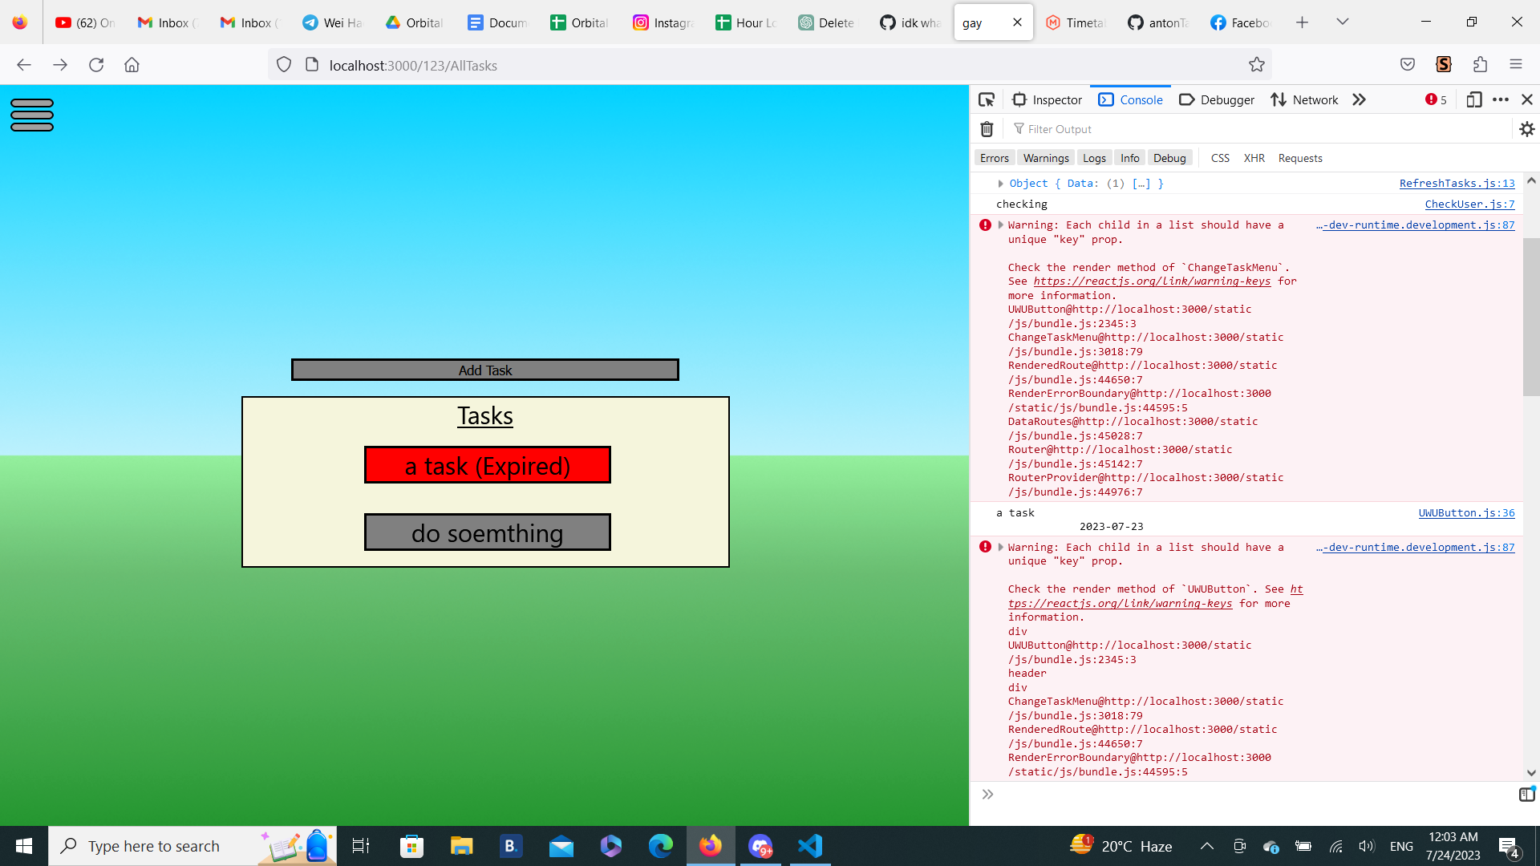

Figure 4.1: Task list with an expired task

This page shows you all the tasks you currently have. You can click the “Add Task ” button to add new tasks to the list, or click on each task to check out more details about the task. Tasks are automatically sorted by deadline, which means that tasks that have a closer deadline will be shown on top of the list. Tasks that expire under 24 hours will become red, and expired tasks will have an (Expired) mark behind it.

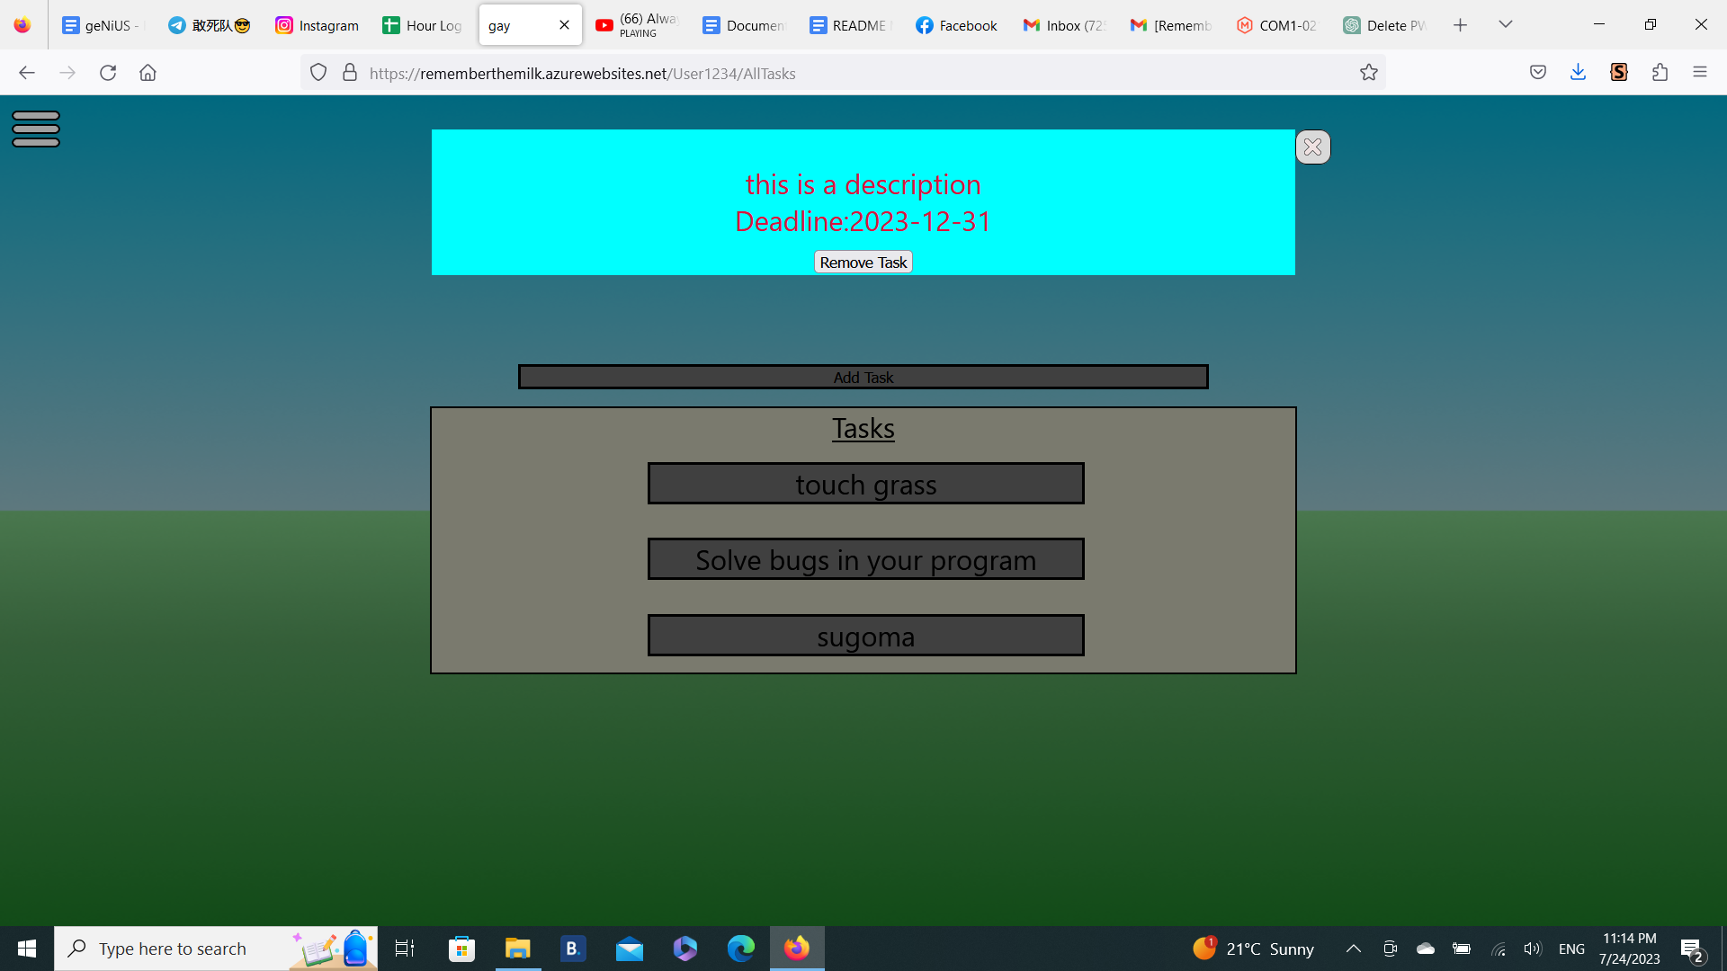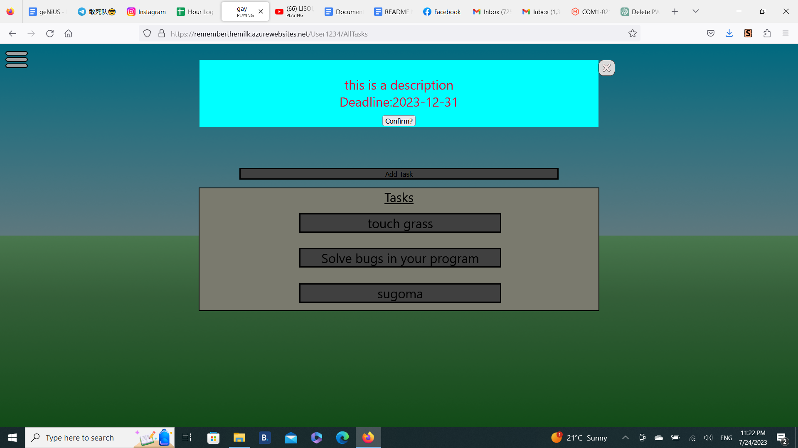

Figure 4.2: Details of a task Figure 4.3: Confirmation of task deletion

After clicking on a task, you will get to see its description, along with its deadline. You also have the option to remove the task from the task list. Upon deleting a task, a sound effect will play and you will have to click the button again to confirm that you want to delete the task.

**Add Task**

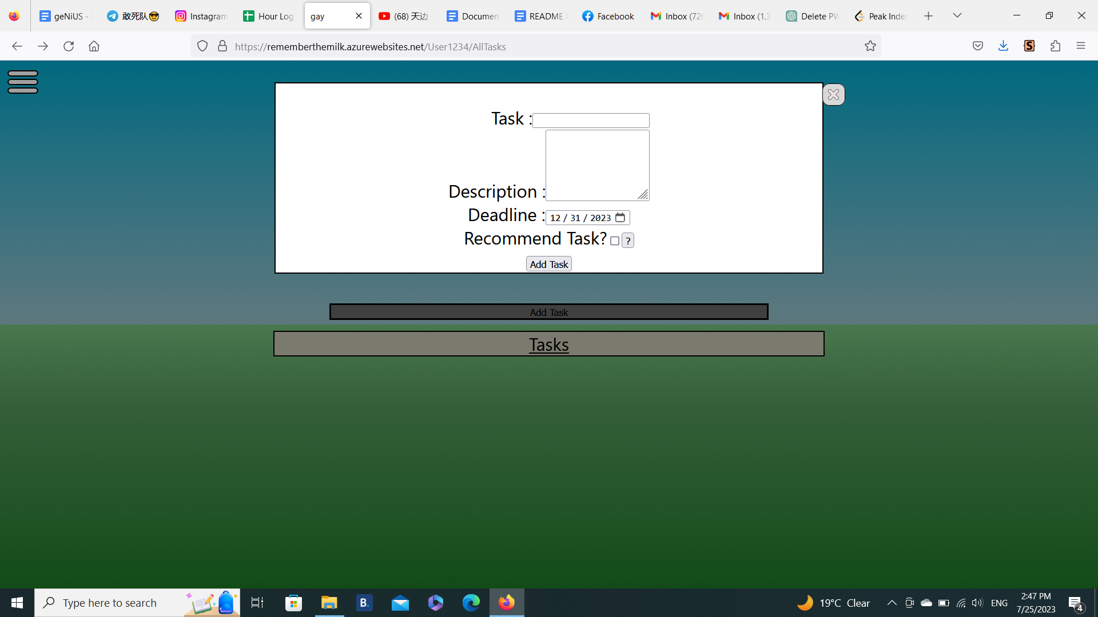Figure 4.4: Interface for adding tasks

When you want to add a task, you are presented with the interface above. A task must have a name, and its deadline must not be before the current date. A description of the task is optional, but in the case that a description is added, it must not exceed 255 characters in length.

When adding a task, there is a checkbox saying whether you want to recommend this task. If you tick the checkbox, your task will be copied to the public task pool, which it may pop up when using the get recommendation feature.

After clicking on the add task button, your task list will be successfully updated.

**Contacts**

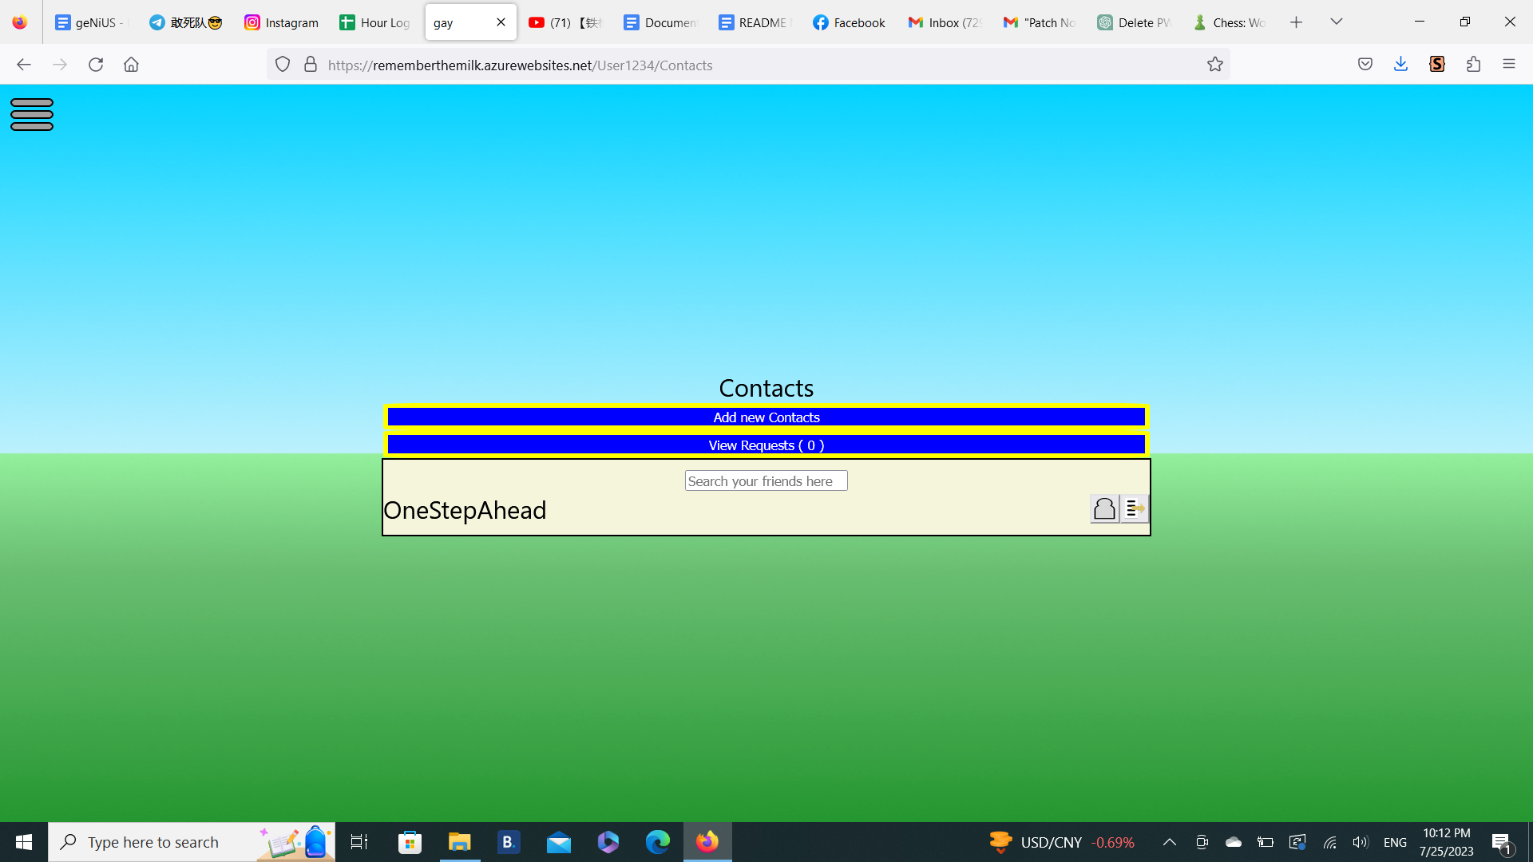

Figure 5.1: List of Contacts

This page shows all of your contacts, and a path to look for new contacts (Add new contacts), and view requests along with the number of requests pending. For each user in your contact list, you can either send a task, or remove the user from your contact list. You can also search for a specific user from your contacts list using the search bar. Upon entering the username, users that have the input as its prefix, and are originally in your contact list will show up in the refreshed list.

**Send Task**

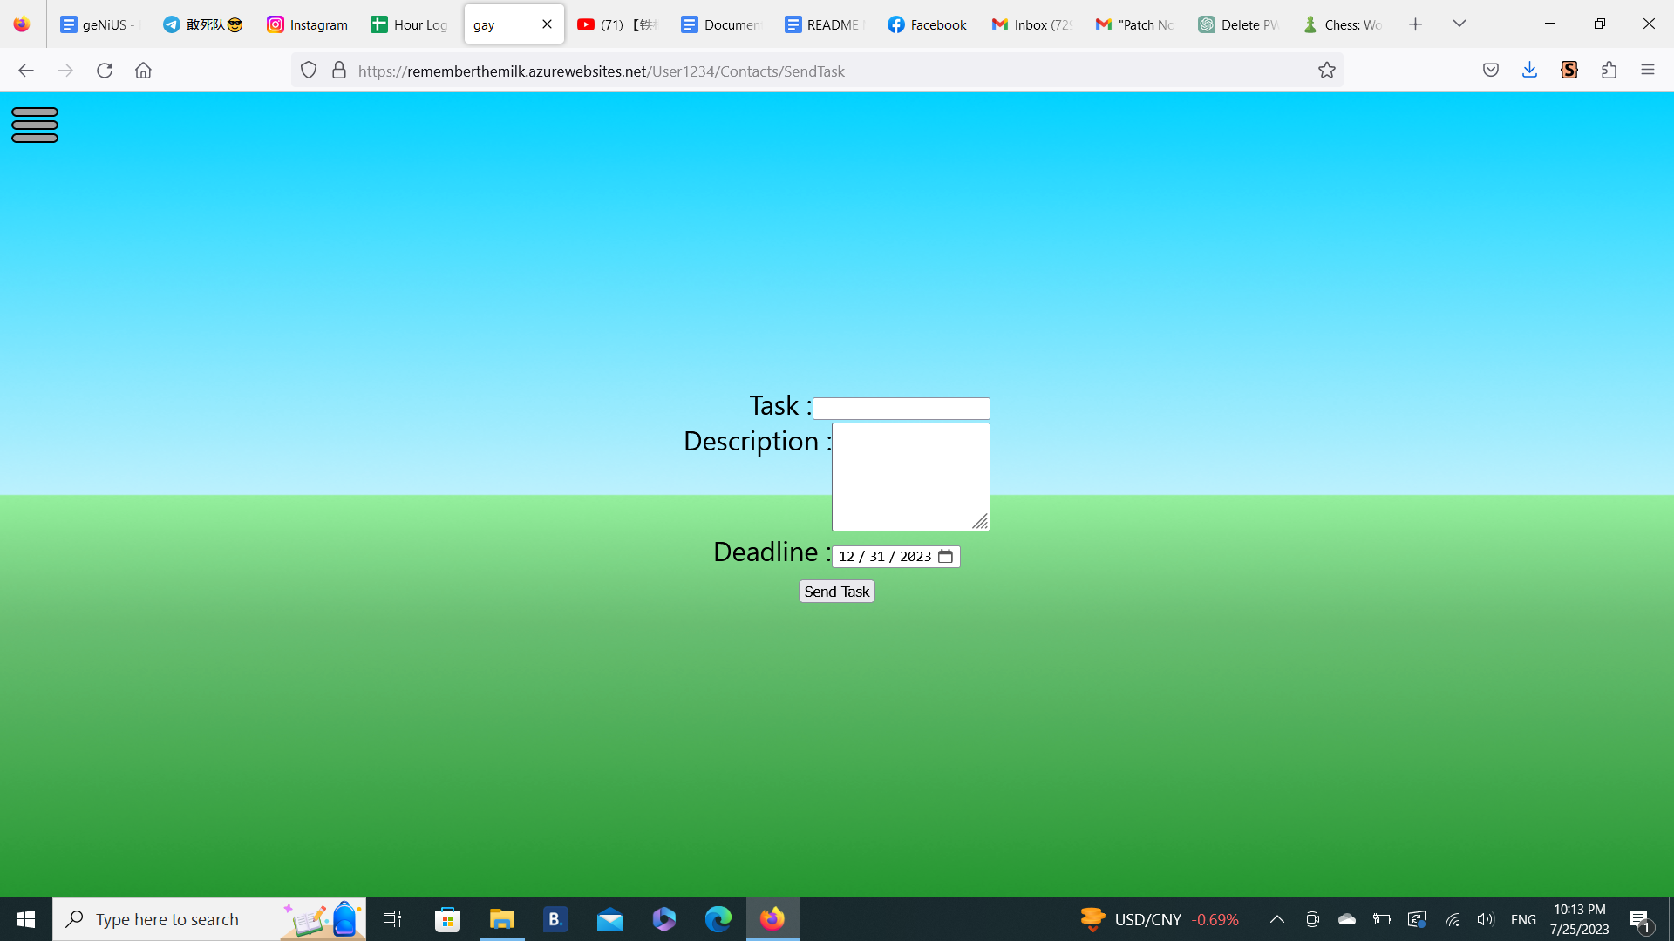

Figure 5.2 Sending task to a friend

When sending tasks to a friend, the requirements are the same: It must have a name, its deadline must not be in the past, and the description must be shorter than 255 characters.

**View Requests**

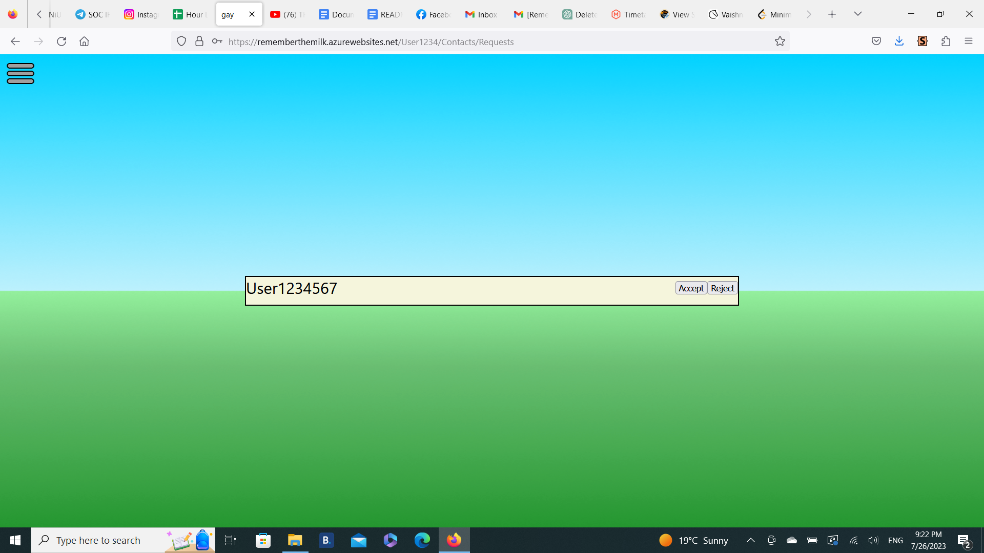

Figure 6: A request sent by User1234567

After clicking on the “View Request” button, you can see who has requested to be your contact. You can either accept the request and add him to your contact list or reject the request.

**Add New Contacts**

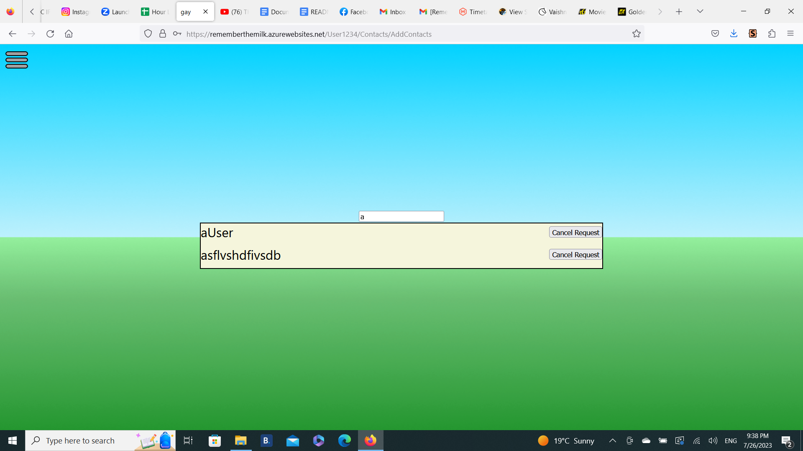

Figure 7.1: List of users with the prefix “a”

You will be brought to this page after clicking on the “Add New Contacts” button in the Contacts menu. You have to provide an input to get a list of users that exclude existing contacts and yourself with the input as its prefix. If you provide an empty string, all existing users will be in the list. If no users have the corresponding input as prefix, the app will let you know that there are no existing users.

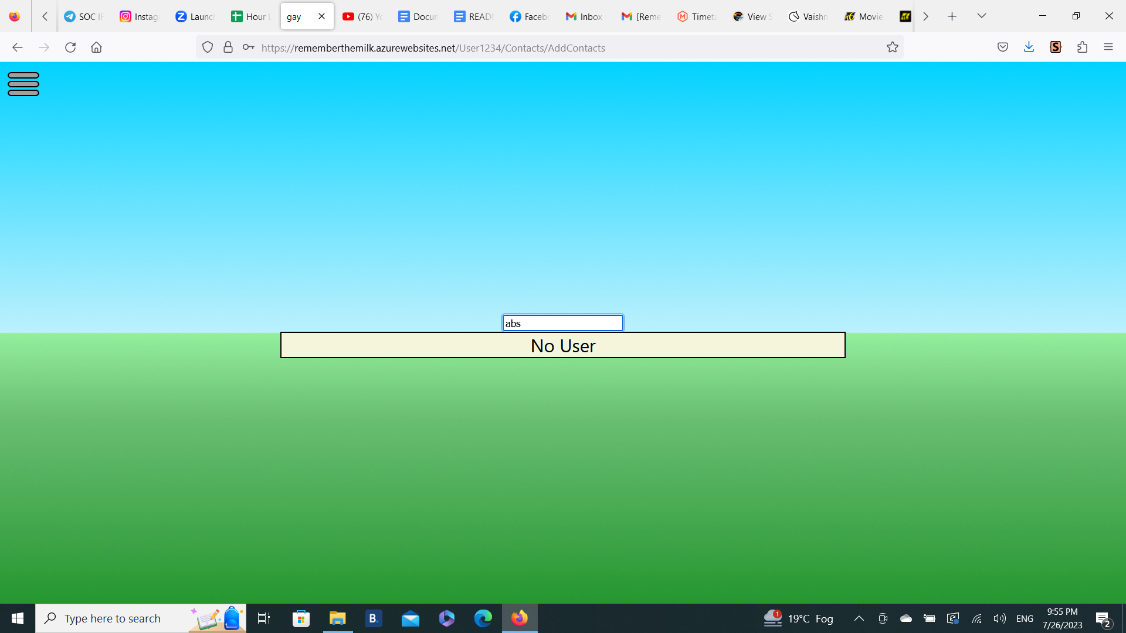

Figure 7.2 List of users that have the prefix “abs”(none)

**Get Recommended Task**

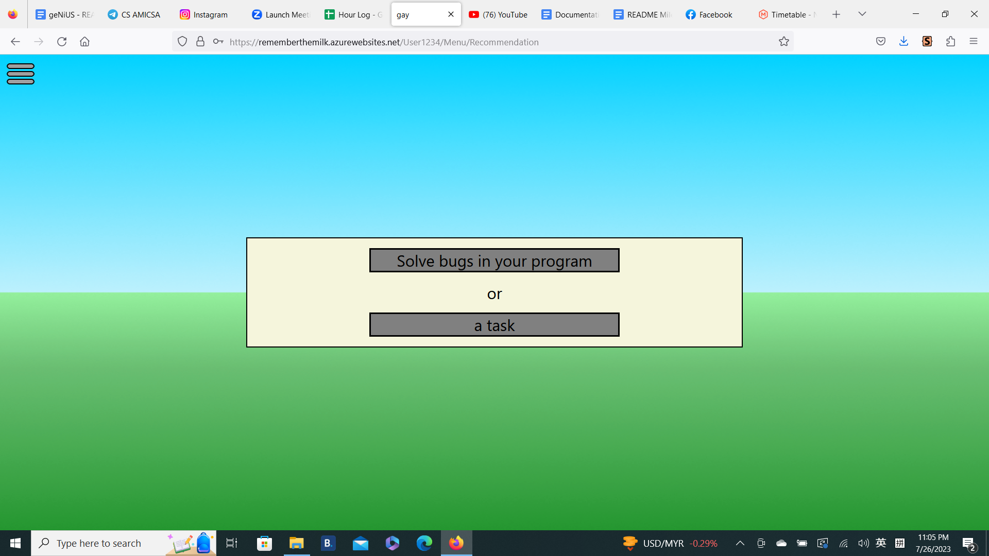

Figure 8: Getting a recommended task

Getting a recommended Task is one of the core ideas of this app, other than sending tasks to other users. When you click on the “Get Recommendation Button”, you get to pick a task between : A new task at the top that originates from a task pool founded by everyone, and a task at the bottom that originates from your existing task list.

If you choose the top task, it will be added to your task list and set as your active task. If you choose the bottom task, it will only be set as your active task. Choosing any task will take you to the Current task page.

**Auto Login**

Accidentally closing your tabs or occasional system crashes are annoying. Therefore, when you open the app you may be taken straight to the Current Task Page instead of the Welcome Page. This feature only works if the last time you entered your password is within 24 hours of current time. If you manually log out, you will not be automatically logged in for obvious reasons.